Fast Track Application Instructions

Step 1: View the Position Listing
To view all open positions and apply, click on “Search”. If you have already applied for a position and want to access to your profile, enter in your username and password then click on “Log In.” If you forgot your username or password, click on “Forgot your username/password?” to have an email sent to you with your information.
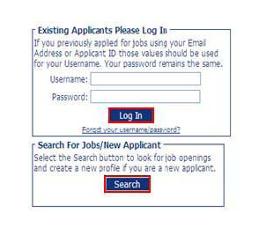
Check the checkbox of the position you want to review and click on “View Details of Selected Position.” At this step you also have the option to apply for the position without reviewing it.

Step 2: Apply for the Job
Review the position listing. The position listing will give you a preview of the questions included in the online application. When you are ready to begin the online application, scroll to the top of the page and click on the “Apply for Position” button.
Step 3: Create an Account (First Time Only)
You will need an e-mail address and password to access the online application. After you click on Apply for Position, you will be asked to either enter your existing username and password or create a new user profile. If this is the first time you have applied for a job electronically with the Bainbridge Island School District check the box that says “I Would Like to Create a New Profile,” enter your information, then click on “Create Profile.”

Please make a note of your username and password as you will need it to access your application profile in the future.

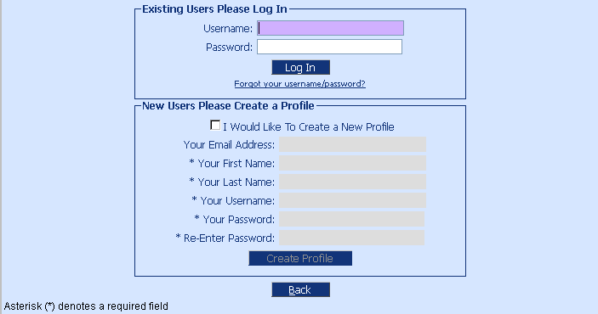

Step 4: Begin your Online Application
There are 8 sections of the application to complete. Each section (except Comments) contains a check box indicating that you have entered the information to the best of your abilities. Checking the checkbox will also change the status of the corresponding section below to “Completed”. When all sections are marked “Complete” or “Optional”, you may submit your application to Human Resources at the right. Once your application has been submitted, you may log back into your profile and make updates to the application until the closing deadline.
Your application is automatically save as you enter data. If you cannot complete your application all at once, just click on the “Return to Profile” button to see that your information for that application was saved and then click on “Log Out”. When you want to return and finish, just log back into the system with your username and password.

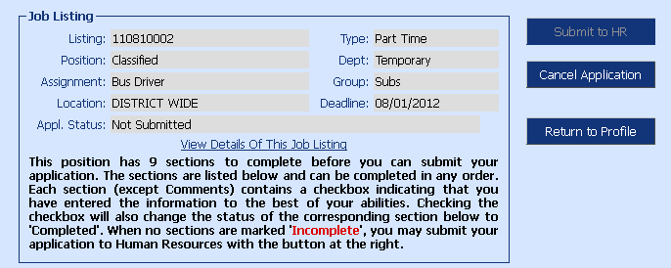

For more information on how to apply for positions, please review the Frequently Asked Questions (FAQs) document. If your questions are still not answered, please feel free to contact us.

Email: jbruns@bisd303.org
Telephone: 206.842.4714

